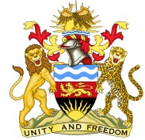
SOUTH EAST EDUCATION DIVISION EXAMINATIONS

2026 MALAWI SCHOOL CERTIFICATE OF EDUCATION MOCK EXAMINATION

CHICHEWA
Subject Number: M032/II Monday, 23 March Time Allowed: 2 hours
1:00 – 3:00 pm
PAPER II
(MALIKISI 90)

MALANGIZO

1. Onetsetsani kuti pepalali lili ndi masamba osindikiza khumi.
- M’gawo A: Malamulo a Chiyankhulo:
Yankhani mafunso onse. (Malikisi 40).
- M’gawo B: Kumvetsa nkhani: Yankhani mafunso onse. (Malikisi 20).

4. M’gawo C: Chifupikitso. (Malikisi 15)

5. M’gawo D: Chimasulilo. (Malikisi 15)
- Lembani Nambala yanu pamwamba pa tsamba lililonse loyankhirapo.
- Perekani pepalali kwa oyang’anira mayeso nthawi ikakwana.

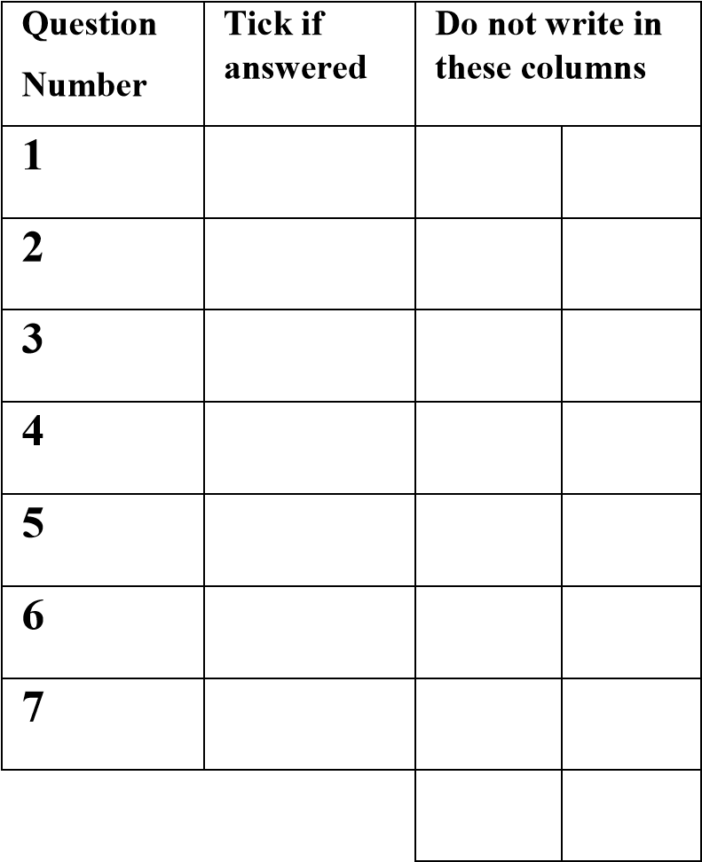

©2026 SEED MOCK Turn over

GAWO A. MALAMULO A CHIYANKHULO (MALIKISI 40)
Malangizo: Yankhani mafunso onse mugawo lino pogwiritsa ntchito malo omwe mwapatsidwa.
1.a. Tchulani mitundu ya anene ameni atsekedwa mizere kunsi kwawo mu ziganizo zotsatirazi.
i. Najere ndi mfumu.
__________________________________________________________ (malikisi 1)
ii. Iwo anali atadya pamene tinafika.
__________________________________________________________ (malikisi 1)
b. Fotokozani mmene mawu otsatirawa apangidwira.
i. mtulo (dzina)
_______________________________________________________________________________________________________________________________________ (malikisi 2)
ii. mwatsopano (muonjezi)
_______________________________________________________________________________________________________________________________________ (malikisi 2)
c. Lembani ziganizo zosonyeza ntchito za aperekezi zotsatirazi ndi kutseka mizere kunsi kwa
aperekeziwo.
- Kusonyeza chida
____________________________________________________________________________________________________________________________________________ (malikisi 2)
- Kusonyeza umwini
____________________________________________________________________________________________________________________________________________(malikisi 2)

2. a. Perekani chitsanzo chimodzi pa mitundu iliyonse ya mimvekero yotsatirayi.
i. mvekero wa fungo
_________________________________________________________________ (malikisi 1)
ii. mvekero wa maonekedwe
________________________________________________________________ (malikisi 1)

Continued/…
b. Sinthani ziganizo zotsatirazi kuti zikhale mu zoyankhula mwini.
i. Aphunzitsi atiuza kuti tikhale chete.
____________________________________________________________________ (malikisi 2)
ii. Amfumu anafuna kudziwa ngati aliyense adafika pa mnsonkhanowo.
___________________________________________________________________________________________________________________________________________________(malikisi 2)
c. Gwiritsani ntchito mneni ‘mata’ mu ziganizo kusonyeza misintho yotsatirayi ndi kutseka
mzere kunsi kwa mneniyo.
- Msintho wotsutsa
__________________________________________________________________________________________________________________________________________________ (malikisi 2)
- Msintho wodzichitira
___________________________________________________________________________________________________________________________________________________(malikisi 2)
3. a. Tchulani mitundu ya mifuwu yomwe yatsekedwa mizere kunsi kwawo mu ziganizo
zotsatirazi.
i. Kalanga ine! Ufa uja wataika.
____________________________________________________________________ (malikisi 1)
ii. Hehede! Ndapambana mayeso.
____________________________________________________________________ (malikisi 1)
b. Fotokozani ntchito za ‘ti’ yemwe watsekedwa mzere kunsi kwake mu ziganizo zotsatirazi.
i. Iye watiombera ndi mfuti.
___________________________________________________________________ (malikisi 2)
ii. Kodi mukupita kuti?
____________________________________________________________________ (malikisi 2)
c. Lembani ziganizo pogwiritsa ntchito mneni ‘bwera’ kusonyeza nthawi za aneni zotsatirazi.
i. nthawi yakale yathayi.
__________________________________________________________________________________________________________________________________________________ (malikisi 2)
Continued/…
ii. nthawi yam’tsogolo yopitirira.
__________________________________________________________________________________________________________________________________________________ (malikisi 2)

4. a. Tchulani kachitidwe ka aneni omwe atsekedwa mzere kunsi kwawo mu ziganizo zotsatirazi.
i. Dzira lija lasweka.
____________________________________________________________________ (malikisi 1)
ii. Suwema wakwera njinga.
____________________________________________________________________ (malikisi 1)
b. Tsekani mzere kunsi kwa nthambi zosaima pa zokha za ziganizo mu ziganizo
zotsatirazi ndi kutchula ntchito zake.
- Tikukuyamikani pa zabwino zonse zomwe munatichitira.
___________________________________________________________________ (malikisi 2)
- Ino ndi nthawi yomwe timaiyembekezera.
___________________________________________________________________ (malikisi 2)
c. Lembani ziganizo zokhala ndi akapandamneni a mitundu yotsatirayi ndi kutseka
mzere kunsi kwa akapandamneniwo.
- Kapandamneni wa mneni wosasintha nthawi
__________________________________________________________________________________________________________________________________________________ (malikisi 2)
- Kapandamneni wa muonjezi
__________________________________________________________________________________________________________________________________________________ (malikisi 2)

Continued/…
GAWO. B. KUMVETSA NKHANI NDI KUSANTHULA CHIYANKHULO
(MALIKISI 20)
Werengani nkhani ili m’munsiyi ndi kuyankha mafunso otsatirawo.

Mudzi wa Mfumu Samalani unatchuka kwambiri chifukwa cha luntha ndiponso khalidwe la Mfumu yawo. Mfumuyi inali ndi luso loweruza milandu mwachilungamo ndi mopanda madyeramphotho. Mafumu ndiponso anthu wamba wochokera ku madera akutali ndiponso apafupi adali pikitipikiti m’mudzimo kudzayamwira nzeru kwa mfumuyo. Motero anthu a m’mudzimo amapindula kwambiri pa chitukuko cha moyo wawo wa tsiku ndi tsiku ndiponso zachuma, pozindikira kuti pasamba mfulu kapolo amasamba pomwepo.

Madzulo a tsiku lina mfumuyo ikulandira mgonero m’nyumba ndi banja lake ndiponso alendo amene adafika pakhomopo, idamva kukhosomola. Mosakhalitsa adamva kuodira. Mfumuyo inatuluka ndipo inapeza munthu ali chiimire pa bwalo. Poyamba mfumuyo siinathe kuzindikira mlendoyo popeza mitambo imene inafunda mlengalenga inali kusinjirira mdima womwe unalipo pa nthawiyo. M’kulonjerana ndi pamene adazindikira kuti adayenderedwa ndi mwana wam’mudzi, Gadabwali. “Ndakulandirani, tiyeni tigwadire pa matabwapo.” Adatero Amfumuwo pomusonyeza Gadabwali kuti walandiridwa ndi manja awiri.

Ataba khonde motero, Gadabwali adamva kumasuka ndikuyamba kumasula mtolo umene adabwera nawo nati, “pepani gogo chalo kukuvutitsani mumdima chotere. Chagwera ine mumsewu ndi chakuti Gwaza wandikolosola. Iyeyu wayesera mfuti yake pa likonyani langa mpaka kulichititsa manyazi. Ndinamufikira kuti tikambirane mwaubale koma wandichita chipongwe. Apo ndi pamene ndati ndikupiteni ku maso pozindikira kuti akuluakulu ndi m’dambo mozimira moto.”
“Chabwino ndakumvani, tsiku la bwalo likakonzedwa ndikudziwitsani”
“Mfumu, ine ndathokoza chifukwa chakundirandira mwachikondi. Ndisanaone msana wa njira gwirani apa zinazo tidzaona ku mapeto a ndime”
“Chabwino, yendani bwino”
Continued/…
Tsiku la mlandu litafika bwalo la mfumu linali lodzaza monga mwa masiku onse kudzachitira umboni chilungamo. Amene anayamba kuyankhula ndi Gadabwali ndipo kenaka Gwaza anapatsidwa mpata wofunsa mnzakeyo mafunso malingana ndi zimene adayankhula pa bwalopo.

“Ulemu Amfumu ndi akulu nonse mwafika pa bwalo lino. Funso langa kwa Gada ndi lotere, ‘kodi mwana amene akulera Nasuluma, mdzukulu wanga bambo ake ndi ndani?’”
Atatero, nduna ina ya mfumu inaima ndikuuza Gwaza kuti kumene anali kuchita ndi kusokoneza chifukwa bwalo silinali la mlandu wokhudza Nasuluma. Gwaza pobweza anauza ndunayo kuti ikhale pansi popeza siimadziwa chimene inali kuyankhula. Gadabwali anangoti kukamwa yasa podziwa kuti zagwera pamphuno. Kenaka mfumu inapereka bwalo kwa Gwaza kuti afotokoze mbali yake.

“Ulemu kwa inu mfumu yanga. Ine pano kunena mosapsatira mawu mlanduwu ndikuuvomera. Izi ndidachita dala. Nasuluma atatenga pathupi panali umboni wokwanira kuti katunduyo adali wa Gadabwali koma iyeyu anakanitsitsa kuti sankadziwa kanthu potengera mwa ububu wa Nasulumayo. Nkhope ya mwana atabadwa ndi yomwe inaulula zonse. Tere ine uku n’kubweza poti mnzako akakuchenjerera pogona iwe umamuchenjerera podzuka. N’kafika apo ndaima.”
“Apa zaonekeratu kuti mtayamakoko saiwala koma mdyanyemba. Iwe Gadabwali chifukwa chochitira nkhanza anthu aulumali ndiponso kufuna kuchita khalidwe la ziphuphu ku bwalo la mfumu ndikukulamula mbuzi zisanu ndi imodzi. Ziwiri za bwalo ndi zinayi zopita kwa Nasuluma. Kandalama kamene unandibweretsera kaja ndi aka. Iwe Gwaza chifukwa chofuna kutengera lamulo m’manja ndikukulamula kulipira mbuzi zisanu.”
Pamene anthu ankachoka pa bwalo lamlanduwo adali wokhutira kuti ndithu chilungamo chimayenda ngati madzi.
MAFUNSO
2. a. Kodi Gadabwali adapeza a mfumu akuchita chiyani pamene anabwera kudzasuma mlandu
wake?
__________________________________________________________________ (malikisi 1)
Continued/…

- Tchulani zinthu ziwiri zosonyeza kuti moyo wa a mfumu unathandiza pa chitukuko cha anthu a m’mudzi mwawo.
__________________________________________________________________________________________________________________________________________________ (malikisi 2)
- Fotokozani mwachidule mlandu umene Gadabwali anakasuma kwa mfumu.
___________________________________________________________________________________________________________________________________________________(malikisi 2)
- N’ chiyani chimene chinapulumutsa Gadabwali poyamba pa mlandu wake ndi Nasuluma. ____________________________________________________________________ (malikisi 1)
- Tsimikizani kuchokera mu nkhaniyi kuti pa dziko la pansi palibe chinsinsi.
__________________________________________________________________________________________________________________________________________________ (malikisi 2)
- Fotokozani khalidwe limodzi la Gwaza malingana ndi nkhaniyi.
__________________________________________________________________________________________________________________________________________________ (malikisi 2)
- Perekani mawu ofanana ndi otsatirawa kuchokera mu nkhaniyi.
i.Nzeru
____________________________________________________________________ (malikisi 1)
ii. Kuonjezera
___________________________________________________________________ (malikisi 1)
- Kodi mfumu inasonyeza motani kuti imadana ndi ziphuphu ndi katangale.
____________________________________________________________________ (malikisi 1)
- Perekani mavuto awiri omwe amadza chifukwa cha katangale m’dziko.
_________________________________________________________________________________________________________________________________________________ (malikisi 2)

- KUSANTHULA CHIYANKHULO
Perekani matanthauzo a mawu otsatirawa:
- Kudzayamwa nzeru
__________________________________________________________ (malikisi 1)
- Tiyeni tigwadire pa matabwapo
__________________________________________________________ (malikisi 1)
- Chagwera ine mumsewu
_________________________________________________________ (malikisi 1)

- Anangoti kukamwa yasa
___________________________________________________________ (malikisi 1)
- Kunena mosapsatira
____________________________________________________________ (malikisi 1)

GAWO C. CHIMASULIRO (MALIKISI 15)
Werengani nkhani yotsatirayi ndi kumasulira m’Chichewa chomveka bwino.
SAFE MOTHERHOOD
Safe motherhood is a reproductive health initiative that took the floor in the recent years. The main objective of the safe motherhood initiative is to ensure that there are safe deliveries and upbringing of children while all conditions are fulfilled.
The conditions among others include having girls having pregnancies at a good and recommendable age. That there should be recommendable child spacing and finally that the children are well nourished. At the end of the day infants and maternal mortality is taken control of.
As such we need to uphold to the principles of safe motherhood to avoid alarming infant and maternal mortality rates.
__________________________________________________________________________________________________________________________________________________________________________________________________________________________________________________________________________________________________________________________________________________________________________________________________________________________________________________________________________________________________________________________________________________________________
Continued/…
____________________________________________________________________________________________________________________________________________________________________________________________________________________________________________________________________________________________________________________________________________________________________________________________________________________________________________________________________________________________________________________________________________________________________________________________________________________________________________________________________________________________________________________________________________________________________________________________________________________________________________________________________________________________________________________________________________________________________________________________________________________________________________________________________________________________________________________________________________________________________________________________________________________________________________________________________________________________________________________________________________________________________________

GAWO D. CHIFUPIKITSO (MALIKISI 15)
Werengani nkhani ili m’munsiyi. Ili ndi mawu 106 Ndipo muifupikitse kuti ikhale ndi mawu osachepera 36 komanso asapitirire 40
KUSINTHA KWA NYENGO
Kusintha kwa nyengo ndi kusokonekera kwa nyengo yokhazikika m’dera. Izi makamaka zimakhudza kayendedwe ka zinthu zoonera za nyengo za chilengedwe monga, dzuwa, mphepo ndi mvula.

Kusintha kwa nyengo kutha kuchitika pa zifukwa za chilengedwe kapena zopangidwa ndi anthu. Zina mwa ntchito za anthu zomwe zimabweretsa kusintha kwa nyengo ndi monga kudula mitengo mwachisawawa, ntchito za m’mafakitale ndi za m’makampani komanso kataidwe ndi katenthedwe ka zinyalala kapena zinthu zosafunikira pakati pathu.
Continued/…
Zotsatira za kusintha kwa nyengo ndi monga kusintha kwa kagwedwe ka mvula, kuonongeka kwa chitchinga cha dzuwa cha m’mlengalenga komwe kumapangitsa kuti dzuwa lidziomba moposera muyezo, zomwe zotsatira zake ndi kuchuluka kwa kubuka kwa matenda osiyanasiyana maka apakhungu.
________________________________________________________________________________________________________________________________________________________________________________________________________________________________________________________________________________________________________________________
______________________________________________________________________________
______________________________________________________________________________
______________________________________________________________________________
______________________________________________________________________________

MAFUNSO ATHERA PANO

